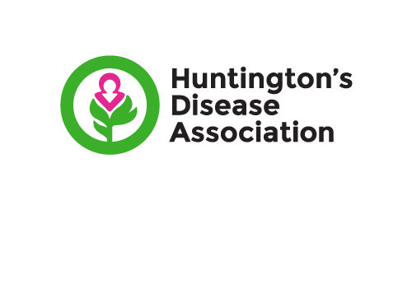

**Agreement for**

**INSERT SUPPORT GROUP NAME**

**Support group agreement**

Introduction

The Huntington’s Disease Association is a registered charity (no 296453) and a company limited by guarantee (no 2021975). We are governed in accordance with our Memorandum and Articles of Association and by a board of trustees called the Executive Council who have overall responsibility for all of our activities and operations.

We value the work support groups do and appreciate their support in enabling us to achieve our goals.

Support groups act in the name and on behalf of the Huntington’s Disease Association and therefore we have a responsibility for their actions. Whilst our philosophy is that support groups should enjoy a degree of autonomy, the principles of best practice relating to the governance of charities dictate that the following formal arrangements laid out in this agreement should be implemented so as to protect against actual or alleged instances of irregularity or financial inconsistency. In the support group’s own interests, it is therefore essential to operate in accordance with this agreement which reflects both the charity and company law rules that the Huntington’s Disease Association is subject to, and act within our policies.

[Any failure of a Support Group to comply with the terms of this agreement (and any directions issued by the Executive Council) shall result in the relationship between the Support Group and Huntington’s Disease Association being immediately terminated and all funds held with the Support Group’s bank account being transferred to Huntington’s Disease Association.]

Guidance

You must discuss with us:

* any part of this document found to be unclear
* any proposed actions you wish to undertake as a support group but are unclear about any associated legalities.

To become a support group of the Huntington’s Disease Association, the leaders of the group must agree this Support Group Agreement. The agreement should then be signed by the support group leaders, dated and sent to us for approval at:

**Huntington’s Disease Association, Liverpool Science Park, Innovation Centre 1,**

**131 Mount Pleasant, Liverpool, L3 5TF**

Once approved, the document will be signed by the Chief Executive of the Huntington’s Disease Association and the Chairperson of the charity’s Executive Council and a copy will be returned to you for your records.

If you are a new support group, the Huntington’s Disease Association will assist your start up by funding your first two meetings (should a free venue be unavailable). By the third meeting, your group should be self-funding.

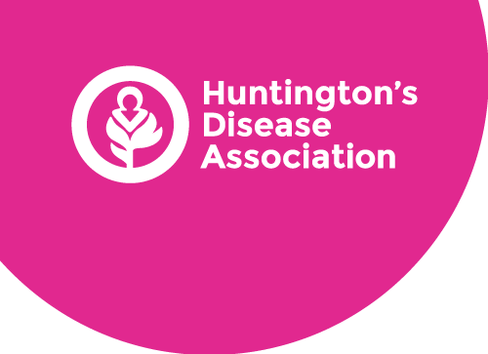

This support group of the Huntington’s Disease Association commit ourselves to help and support people affected by Huntington’s disease and their families, in accordance with the aims and objectives of the Huntington’s Disease Association.

We will:

* arrange meetings of groups and individuals and maintain contact with families affected by Huntington’s disease, and other supporters.
* promote awareness of the Huntington’s Disease Association and Huntington’s disease.
* consult with our members about our activities to identify their needs.
* welcome all those interested in becoming a member of the support group.
* inform all support group members of the benefits of becoming a member of the Huntington’s Disease Association, which is additional to becoming a member of the support group. We will provide Huntington’s Disease Association membership forms to those who wish to become members.
* respond sensitively to all enquiries, treat each person as an individual and build good relationships with people with Huntington’s disease and their families and where appropriate local professionals.
* ensure confidentiality is maintained when discussing individuals or when any notes that are kept in accordance with our confidentiality policies and the requirements of the UK General Data Protection Regulations (UK GDPR) and other relevant legislation.
* treat membership lists and the personal and private affairs of individual members as confidential information. We will comply with the UK General Data Protection Regulations (UK GDPR) guidance and other relevant legislation.
* use a dedicated support group email address for all support group email communication
* use the current Huntington’s Disease Association logo and branding for support groups (in accordance with all guidelines issued by the Huntington’s Disease Association).
* contact the Huntington’s Disease Association for further help, support and advice, publicity materials, literature and publications.
* use the Huntington’s Disease Association’s registered charity number 296453 in all communications with third parties.
* in exceptional circumstances the support group may consider it necessary to open a bank account in addition to operating a petty cash system. If such an account is proposed, one of the signatories must be a member of the charity with authorised signatory responsibility (e.g. trustee or staff member with finance responsibility), who can communicate with the Bank in the event of unavailability of support group signatories.
* If a bank account is opened, the following must be observed, the name of the account should follow the agreed format, (‘XXXX HDA Support Group’) and you must send bank statements to the Huntington’s Disease Association twice a year (to show accounting up to 31 March (the end of the financial year) and accounting up to 30 September (midpoint of the financial year). Huntington’s Disease Association has legal obligations to submit accounts to both Companies House and the Charity Commission annually and these bank statements are necessary in order to meet these obligations.
* hold no more than £300, either in a petty cash system or a bank account. We understand that this bank account is for the collection of small donations, subs from meetings (if collected), raffle money from meetings etc. and can be used to pay for the running of the Support Groups e.g. meeting room hire, refreshments, postage etc. We will transfer any money over £300 to the Huntington’s Disease Association.
* send any money raised by the Support Group to the Huntington’s Disease Association. We understand that this can be ring-fenced for a particular purpose on written request (and subject to the of Huntington’s Disease Association) when the money is sent to the Huntington’s Disease Association.
* contact the Huntington’s Disease Association for guidance and documentation if, as a group, we decide we want to become a branch of the Huntington’s Disease Association to be able to fundraise locally and utilise our bank account for this purpose.
* follow the guidance described within this agreement and all other Huntington’s Disease Association policies and procedures.

our Support Group will declare in writing any professional role or interest outside of our Support Group, which may give rise to a conflict of interest or loyalty with the work of the Support Group or wider charity. These must be detailed in appendix A of this document and the details notified to other Support Group members and sent to the Huntington’s Disease Association.

* any Support Group member is not representative of any other company or organisation to which they are professionally or voluntarily connected.

We, the undersigned, agree to this agreement on behalf of the Support Group

**Support group leader 1**

|  |  |  |
| --- | --- | --- |
| **Name (print)** | **Address** | **Signature** |
|  |  |  |
| **Date signed** |
|  |
| **Phone** | **Email** | |
|  |  | |

**Support group leader 2**

|  |  |  |
| --- | --- | --- |
| **Name (print)** | **Address** | **Signature** |
|  |  |  |
| **Date signed** |
|  |
| **Phone** | **Email** | |
|  |  | |

**Support group leader 3**

|  |  |  |
| --- | --- | --- |
| **Name (print)** | **Address** | **Signature** |
|  |  |  |
| **Date signed** |
|  |
| **Phone** | **Email** | |
|  |  | |

This support group agreement is approved by the below representatives of the Executive Council on behalf of the Huntington’s Disease Association.

_______________________ ______________________

Professor Hugh Rickards Cath Stanley

Chair Chief Executive

______________________ ______________________

Date Date

**Appendix A – Declaration of potential conflict of interest**

*Support Group Leader 1*

Please use this form to report any potential conflict of interest which could arise during your time as a support group leader.

|  |  |
| --- | --- |
| **Name of Support group** |  |
| **Your name and contact details** |  |
| **Role in the group** |  |
| **Details of potential conflict of interest** |  |
| **Action to be taken to mitigate conflict of interest** |  |
| **Date recorded** |  |
| **Date sent to the Huntington’s Disease Association** |  |

**Appendix A – Declaration of potential conflict of interest**

*Support Group Leader 2*

Please use this form to report any potential conflict of interest which could arise during your time as a support group leader.

|  |  |
| --- | --- |
| **Name of Support group** |  |
| **Your name and contact details** |  |
| **Role in the group** |  |
| **Details of potential conflict of interest** |  |
| **Action to be taken to mitigate conflict of interest** |  |
| **Date recorded** |  |
| **Date sent to the Huntington’s Disease Association** |  |

**Appendix A – Declaration of potential conflict of interest**

*Support Group Leader 3*

Please use this form to report any potential conflict of interest which could arise during your time as a support group leader.

|  |  |
| --- | --- |
| **Name of Support group** |  |
| **Your name and contact details** |  |
| **Role in the group** |  |
| **Details of potential conflict of interest** |  |
| **Action to be taken to mitigate conflict of interest** |  |
| **Date recorded** |  |
| **Date sent to the Huntington’s Disease Association** |  |